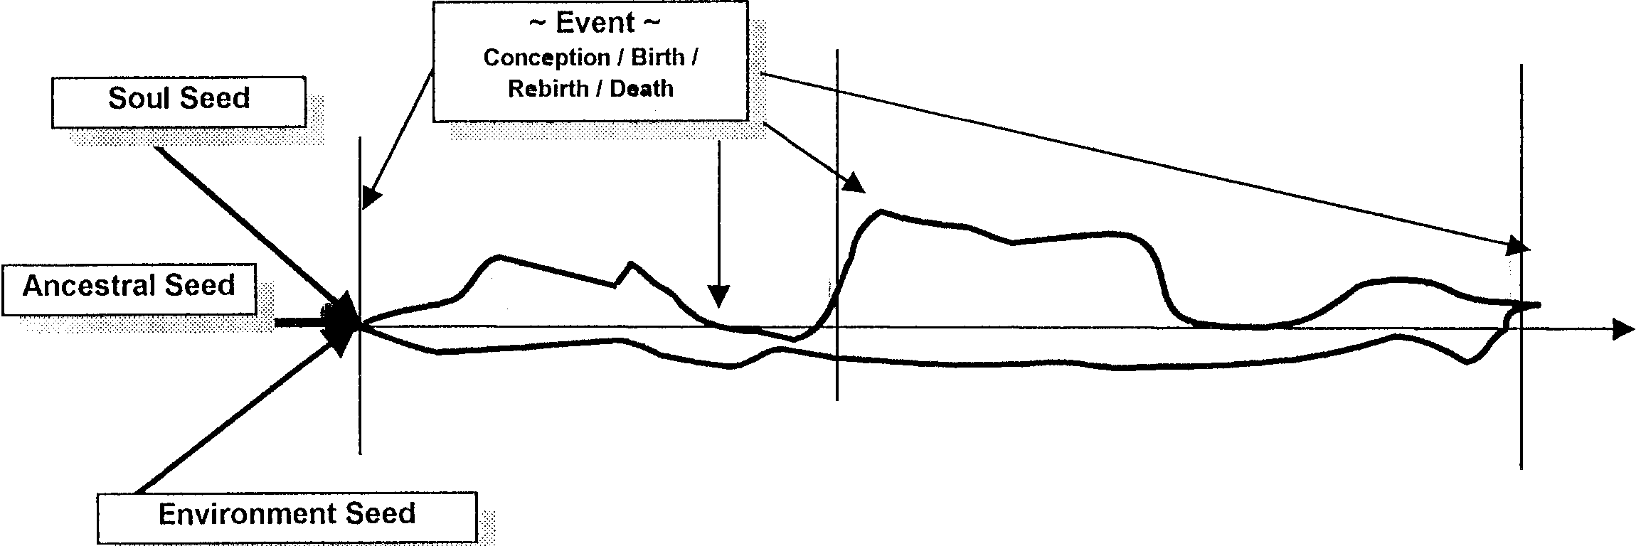

Transformation

Transition
Soul Path
Trauma
EVENT
Soul – Personality Path

