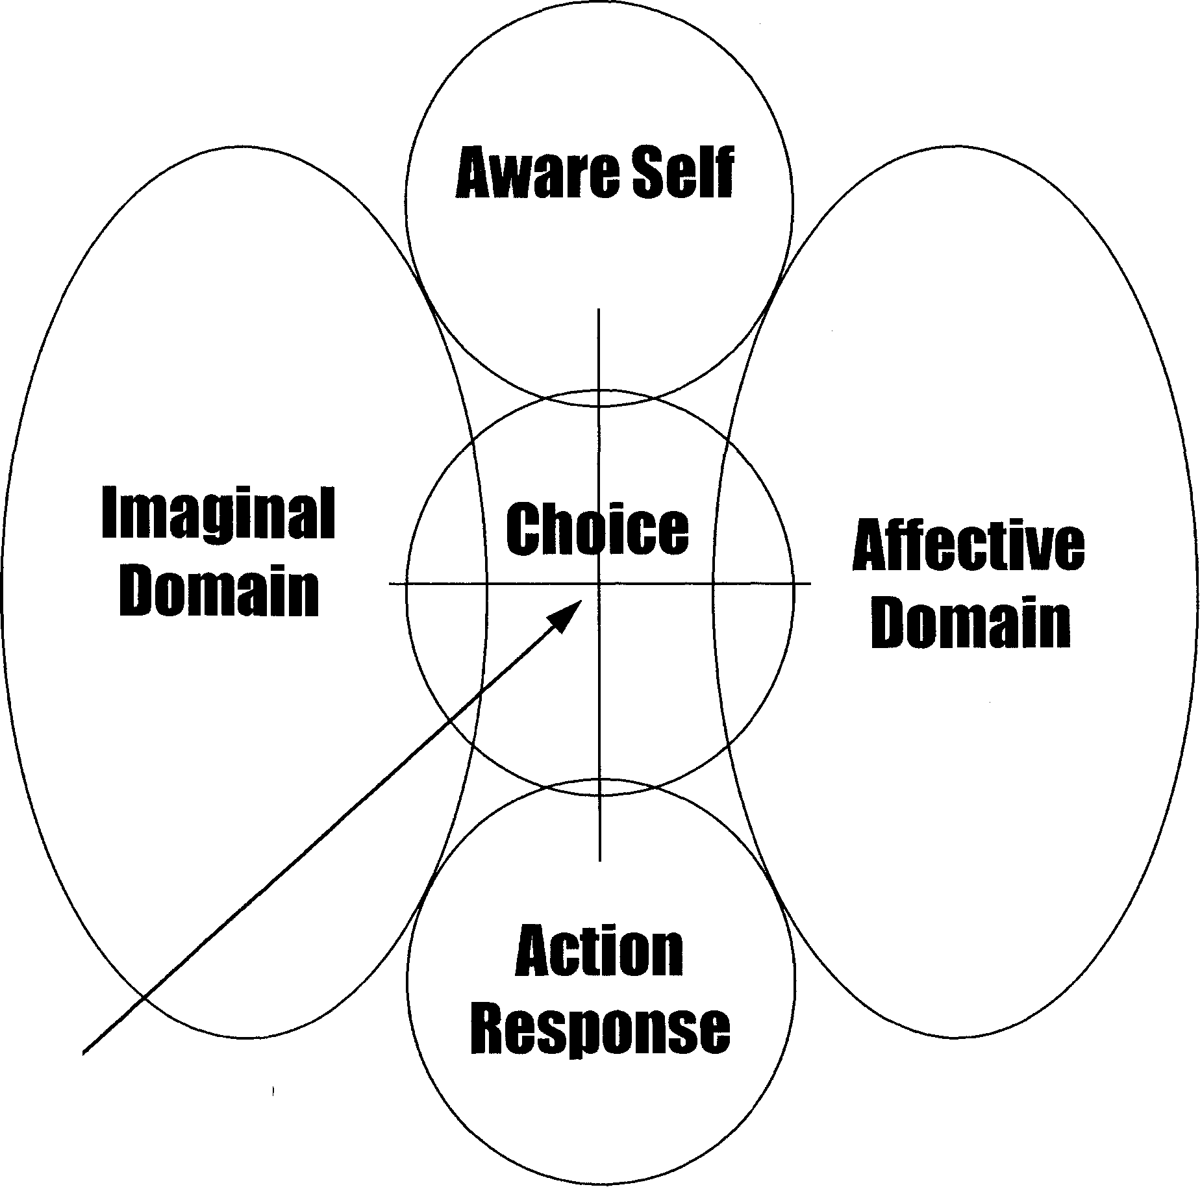
Soul-Cell Connection
Mind

Body
Figure A: Reentry Vehicle (Butterfly]

