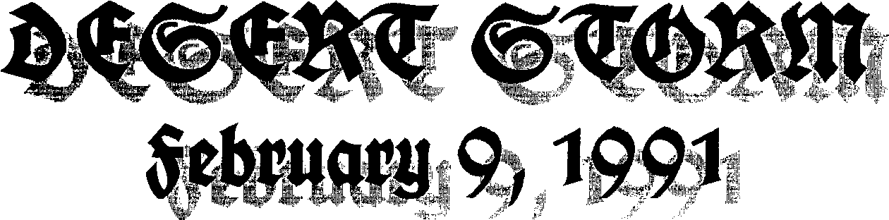

Winter storm clouds burn on desert sands. A thousand points of light, fly on distant wings beams of precision timed to kill.
Ages of truth buried in distorted visions, "Our boys have the best." Gas masks from archives of distant wars. Smart bombs that stray in the face of smog and smoke. Like minds formed in cryogenic chambers, a wasteland of cold-wars waiting to thaw and burn like a prairie fire vision across the land. Unopposed Desolation.
A new world order
born of latent fire.
Have we learned yet
to read lines drawn in desert sands
or writ secretly on a leaders hips?
What code reveals truth inscribed thereon?
Would we want to know?

Rather we follow loyally words spoken eloquently, crafted well, inspired? drawing our eyes away from lips whose deeds are fashioned behind well screened veils.
How well tailored
our ethic of deniability.
"I can't recall"
The ultimate in individuality,
freedom, responsibility.
Now unopposed, we shape a world sterilized for a common palate, deeds filtered and poisoned, designed to serve our righteous vision. Our right is your obligation. How can you not understand, ungrateful waif? Our rules of love and war are all that you deserve.
Can you not see that prisons,
oil spills, acid rain, famine, poverty and war,
are but a small price to pay,
for a kinder gentler America?

Fred C. Olsen, M.Div.

